Assignment 11

LinkedIn

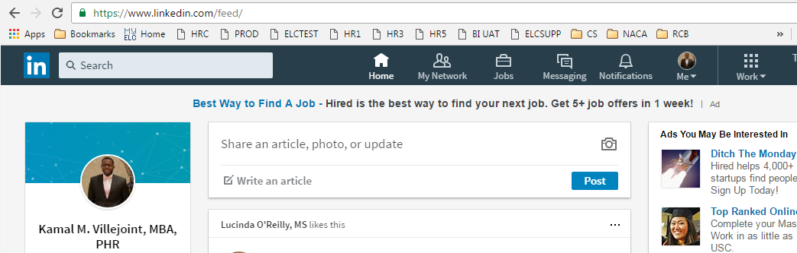

Stack Overflow

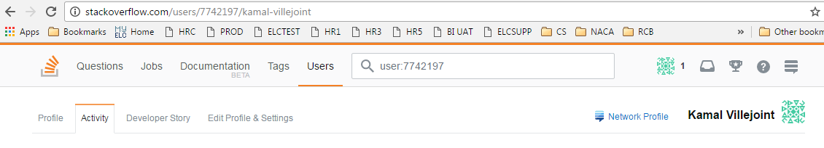

BuiltIn NYC

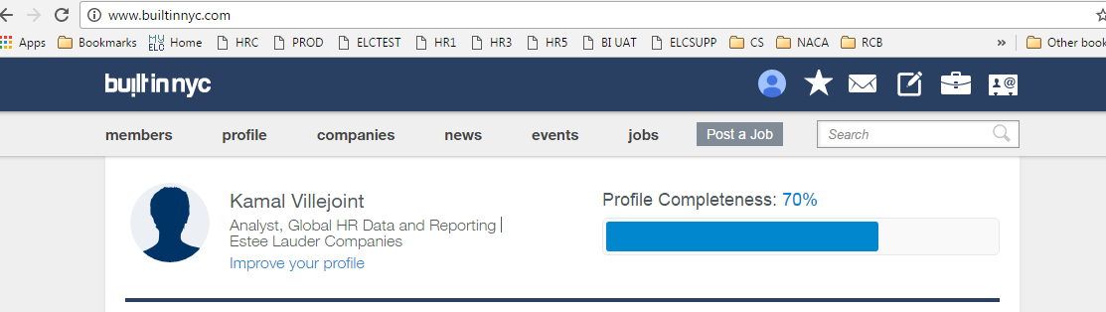

Angel List

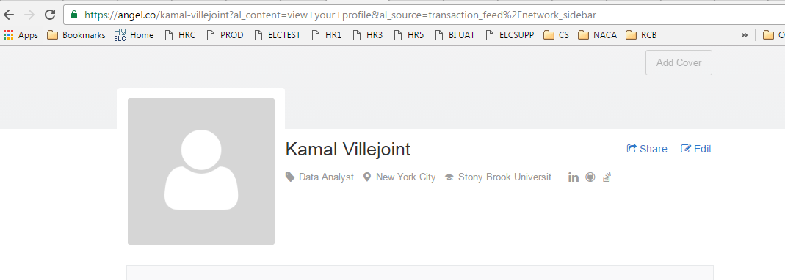

Meetup

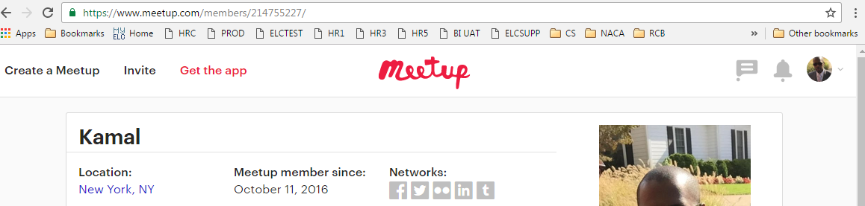

Interview Weekly

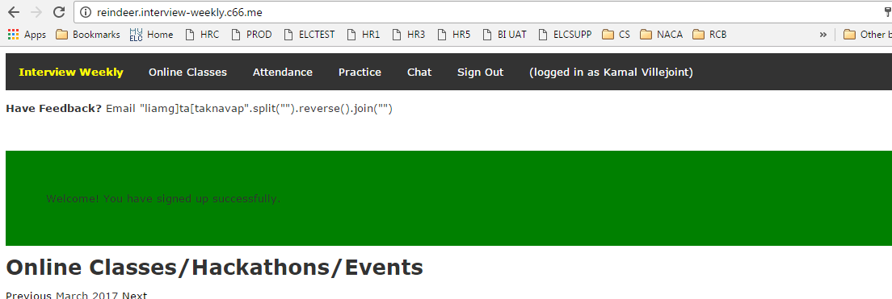

Medium

